Permits Online Help Center:
TTBGov - Request to have Records for Applications filed on Paper Linked to Your Account
TTBGov - Request to have Records for Applications that were filed by a Colleague Linked to Your Account
Step 2: Identify authority
You must have signing authority or power of attorney on file with TTB before we can give you access to existing permits, registrations, or notices. Step 2 asks for the information we need to verify you have authority to access the records you seek.
If you do not already have either signing authority or power of attorney on file with TTB, we require that someone at the business with signing authority, file an amendment granting authority before you submit a request to have the records linked to your account. If, however, this is not possible, you may attach documentation of authority in step 4.

Permits Online Request for Access Application:
You must have signature authority or power of attorney in order to be linked to existing permits, registrations, or notices. If your authority to access requested records is not already on file with TTB, your link request may be denied and someone with authority must submit an entity amendment to add your authorization prior to submitting another request for access. If, however, this is not possible due to a change in control or removal of the application contact, etc., supporting documentation must be attached in Step 4. Please be sure to notate the reason for the request.
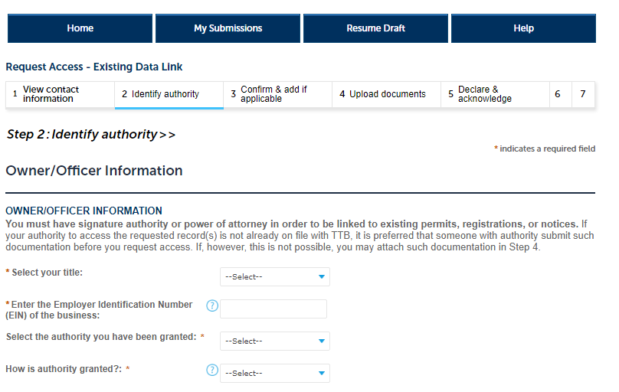

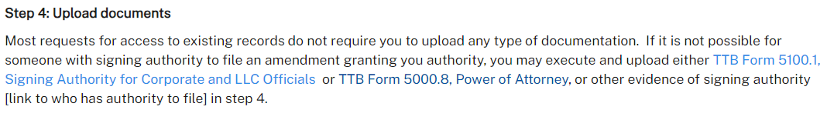

Add (in red if possible): Be sure to notate the reason for the request in the Description field when uploading documentation or submit a letterhead notice identifying the reason.
